**Misr International University**

**Course Code & Title: SWE320/SE305 Software Engineering**

**Semester: Fall 2025**

**Lab manual 2**

1. **Superglobals:**

* Predefined PHP variables.
* Regardless of the scope of superglobal variables, they are always accessible from any function, class or file.
* They are:
  + $GLOBALS: PHP stores all global variables in an array called GLOBALS. To access a variable from globals, you write the variable name in the index:

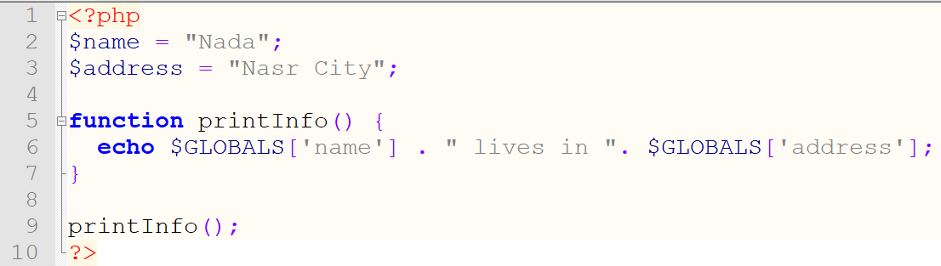

* + $_SERVER: Holds information about headers, paths, and script locations.

Know different elements of $_Server via <https://www.w3schools.com/php/php_superglobals.asp>

* + $_REQUEST: Used to collect data after submitting an HTML Form.
  + $_POST: Used to collect form data after submitting an html form with method= “post”. Used to pass variables.
  + $_GET: Used to collect form data after submitting an html form with method = “get”. Used to collect data sent in the URL.

1. **Sessions:**

Storing information to be used across multiple pages.

1. Starting a session – must be the very first thing in the document before any html tags:

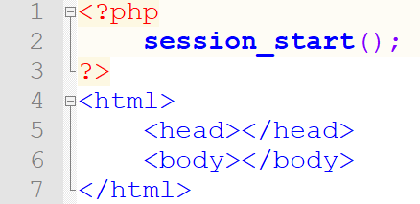

1. Setting session variables – we use the $_SESSION superglobal:

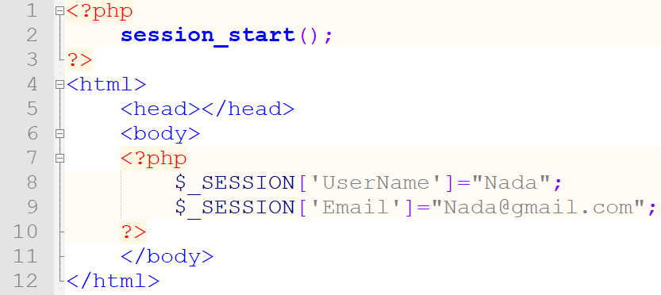

1. Accessing the Session variable values (within same php file or another):

The script above is from test.php file, the script below is from test1.php file where a session is started and the username and email are accessed from the session superglobal:

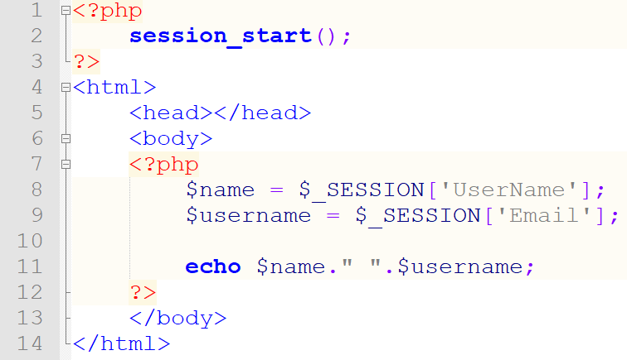

Note: You may change the session variable by simply overwriting it.

1. Destroying a session:

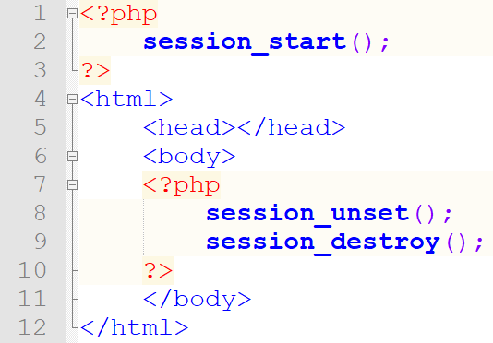

session_unset() – removes all session variables.

session_destroy() – destroy the session.

1. **Include**

This saves a lot of work as you may create a standard header, footer, menu, etc.. file for all of your webpages only once and include it. If, for example you need to update something in the menu it’s updated only once in the menu file that has been included in the webpages.

Syntax:

**include ‘filename’;** Or **require ‘filename’;**

If for example, we have php file menu.php having a menu as follows:

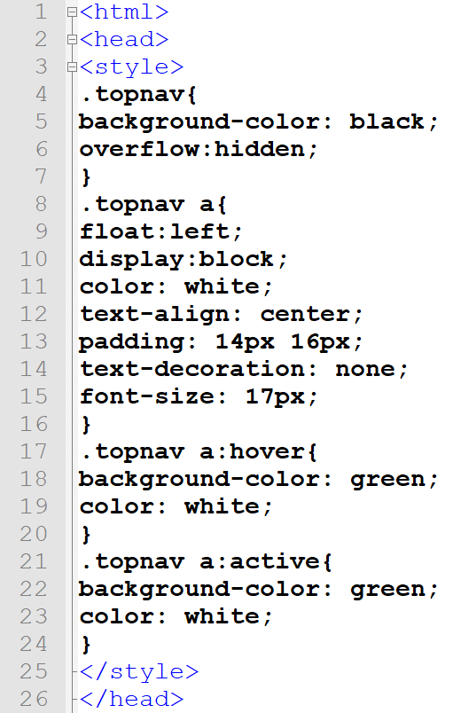 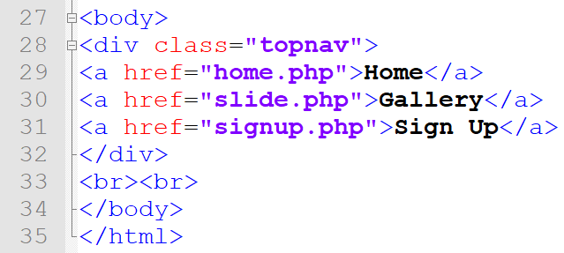

It could easily be included in any web page as follows:

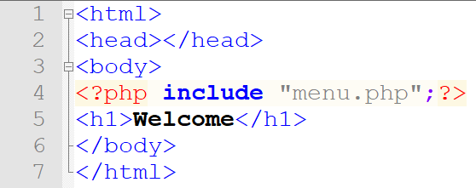

Require vs include

* + Use **require** when the file is required by the application.
  + Use **include** when the file is not required and application should continue when file is not found.

1. **Database Connection**

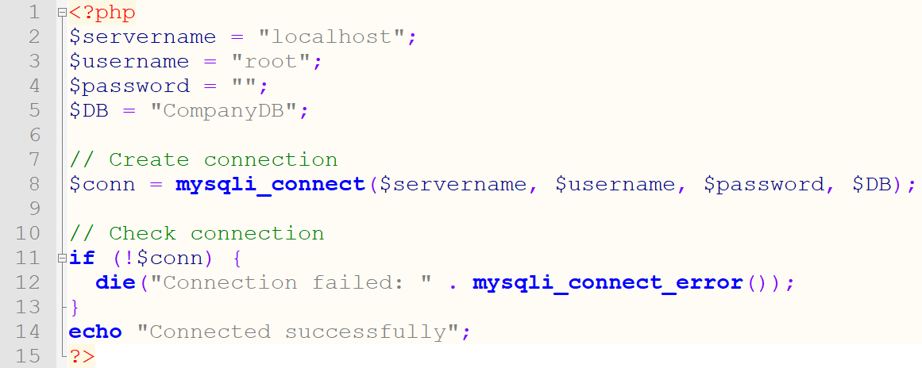

1. **Insert**

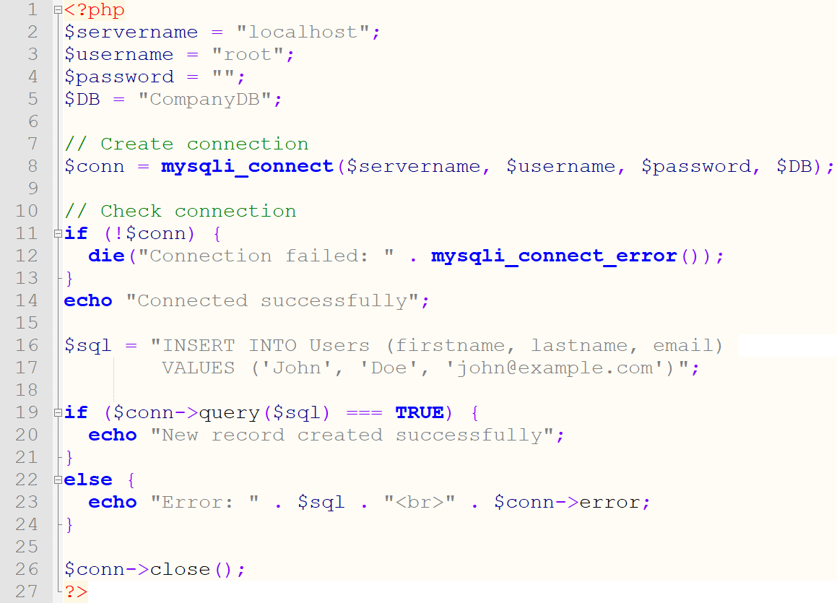

**Section 2 – Exercises**

1. Create a php page that contains the following form

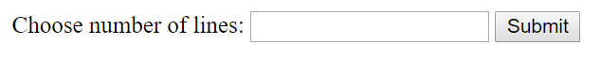

* 1. After submitting, Floyd triangle should appear with n lines (n is the input from the user)

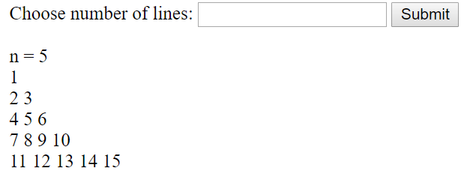

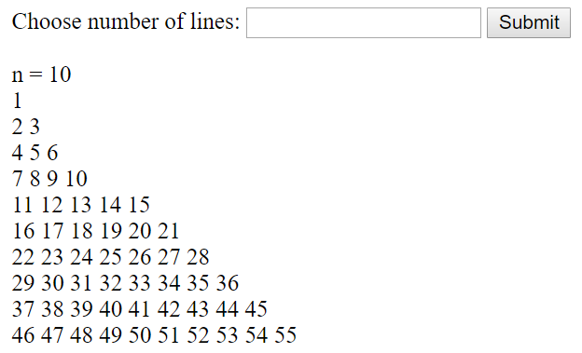

1. Implement the following:
   1. Create the following menu which includes 3 href:

* Home.php
* Gallery.php
* SignUp.php

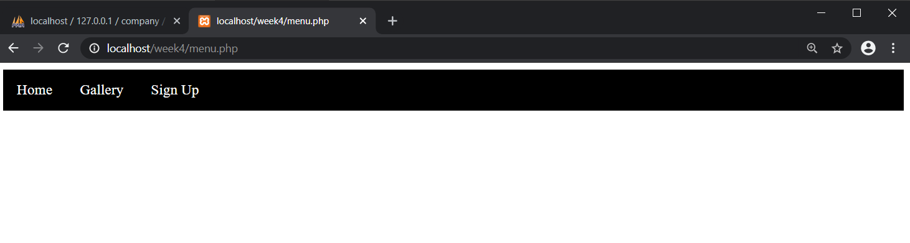

* 1. You Home page should look like this
* Include the menu
* Welcome

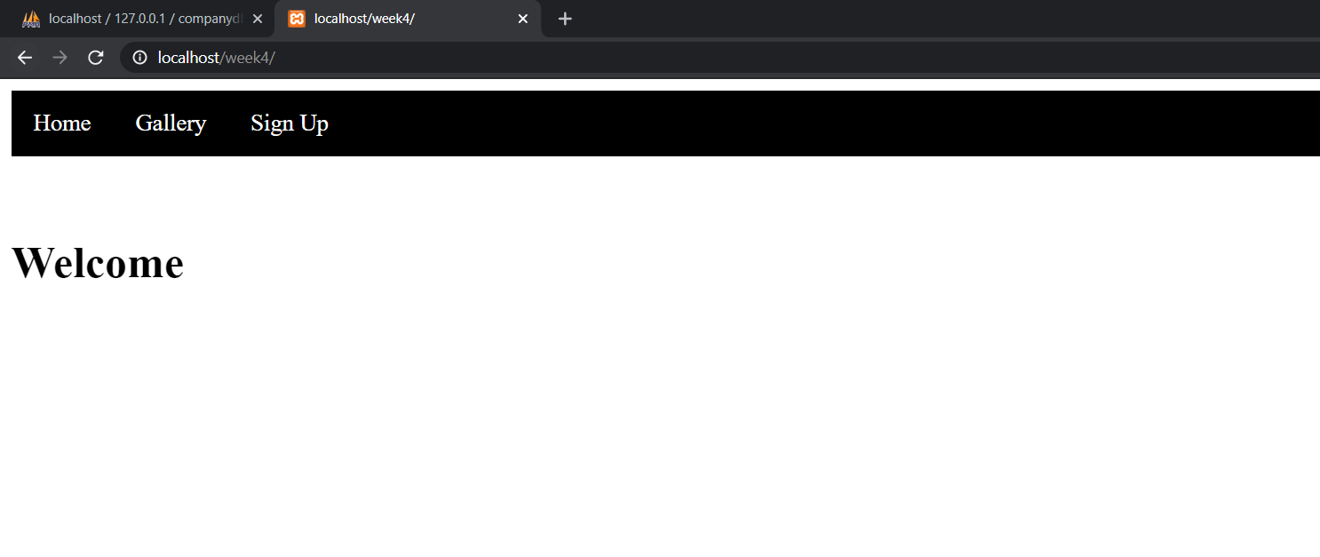

* 1. The Gallery should contain:
* Menu
* Automatic Slideshow

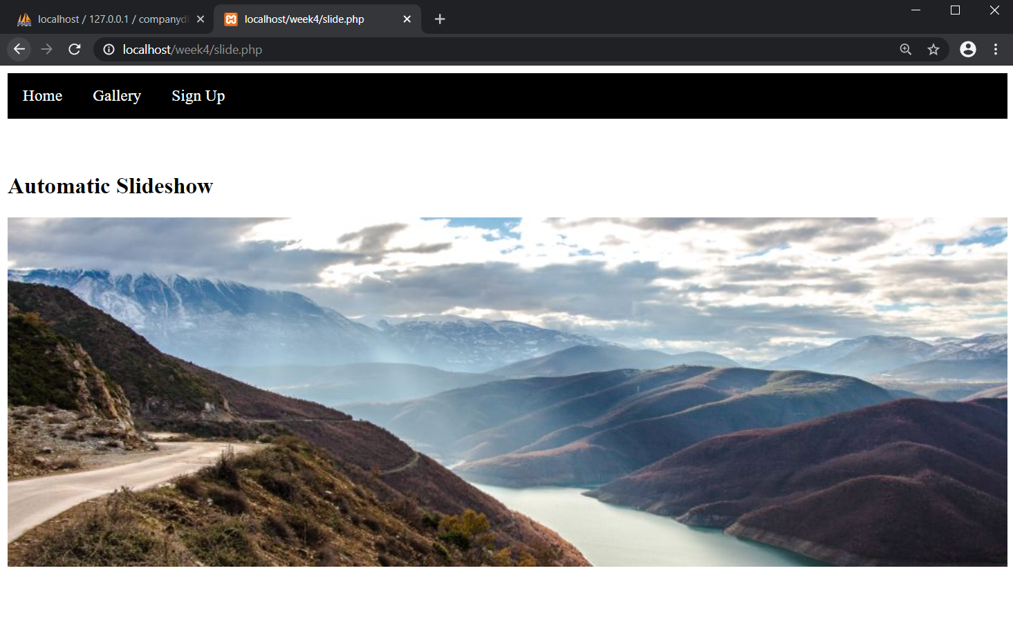

* 1. Sign up should contain
* Menu
* The following form

